A drawing of a cartoon character

Description generated with high confidence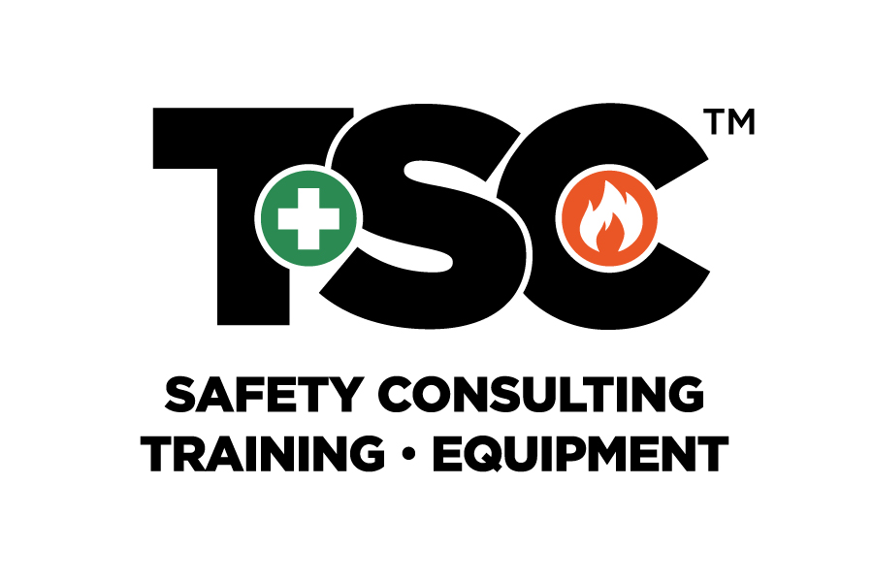

|  |  |  |  |  |  |
| --- | --- | --- | --- | --- | --- |
| |  |  | | --- | --- | | Contact: | Dennis Kiefer <dkiefer@agcnys.org> | | Website | agcnys.org | | FOR IMMEDIATE RELEASEMarch 13, 2018 |

agc nys announces partnership with TSC to host ‘keeping NYC safe’ Educational workshopS and offer its members additional Discounts on Services

The AGC NYS represents contractors and related companies which are dedicated to the ideals of skill, integrity and responsibility. For over 90 years AGC NYS has delivered a variety of services and programs organized to protect the interests of its members. The AGC NYS strives to quickly adapt to meet the challenges confronting their constituents and New York State’s Construction industry.

The AGC NYS has entered into a collaborative agreement with Total Safety Consulting, LLC. (TSC) to provide the digital presentation, tools, resources, and educational materials for this Series; and is aimed at fostering common goals between the organizations to provide the construction industry with beneficial tools and resources they have come to expect as AGC NYS members and clients of TSC.

TSC and its affiliated companies are focused on construction safety by providing the construction industry with jobsite safety consulting, professional safety personnel, safety supplies and equipment and a full curriculum of over 75+ construction safety/general safety training classes.

Safety Supplies Unlimited, LLC. (SSU) an affiliated company of TSC will provide a 10% discount for all products and services to all AGC NYS members. TSC Training Academy (TSCTA) an affiliated company of TSC will offer a 15% discount to all AGC NYS members.

TSC safety personnel, Director of Field Operations, John Connolly and Director of Plans & Logistics, Peter Simon are industry experts that will offer guidance, suggestions and professional direction at the first educational workshop in the Breakfast Series themed, “NYC DOB is at my Jobsite, Now What?” on March 27th at The Downtown Association in NYC.

“AGC NYS is dedicated to delivering a variety of services and programs aimed at protecting the interests of its members, said *Dennis Kiefer, Director of Member Services*. “Collaborating with TSC, a leader in construction safety will help us further our commitment of providing members with the tools and resources they need to navigate the construction safety challenges confronting our industry.”

“For more than 20 years, TSC has been dedicated to improving construction safety and providing our clients with the resources they need to navigate the complexities of building in New York.  TSC provides innovative safety solutions, such as safety consulting, highly-skilled safety professionals, safety equipment and extensive training all aimed at making jobsites more productive by preventing injuries, accidents and eliminating the needless delays and costs caused by them,” said *Jim Bifulco, Managing Member of Total Safety Consulting, LLC*. “We are thrilled to team up with the AGC NYS and bring its members a variety of resources such as safety training, discounts on safety supplies and incredibly important educational seminars all geared at helping construction companies prevent injuries and accidents making jobsites safer.”

# # #

If you would like more information about this topic, please contact:

**Dennis M. Kiefer**

Director of Member Services

AGC NYS, LLC

10 Airline Drive, Suite 203

Albany, NY 12205

P:  518-456-1134

C:  518-376-8221

F:  518-456-1198

E:  [dkiefer@agcnys.org](mailto:dkiefer@agcnys.org)

W:  [www.agcnys.org](http://www.agcnys.org/)

*The AGC NYS is a chapter of the Associated General Contractors of America.*

